| ​​import matplotlib.pyplot as plt  import seaborn as sns  import matplotlib.pyplot as plt  height = [62, 64, 69, 75, 66, 68, 65, 71, 76, 73]  weight = [120, 136, 148, 175, 137, 165, 154, 172, 200, 187]  ______fill the blank______  plt.show() |  |
| --- | --- |

Q1) The left side of the table shows python code, and the right side shows the resulting image from the code. There is one line (in red) missing. What one of the followings shall be filled in the blank above:

A: sns.scatterplot(x=height, y=weight)

B: sns.scatterplot(x=height, y=weight, data = df)

C: sns.displot(x=height, y=weight)

D: sns.kdeplot(x=height, y=weight)

Ans: A

| import seaborn as sns  import matplotlib.pyplot as plt  gender = ["Female", "Female", "Female", "Female","Male", "Male", "Male", "Male", "Male", "Male"]  ______fill the blank______  plt.show() |  |
| --- | --- |

Q2) The left side of the table shows python code, and the right side shows the resulting image from the code. There is one line (in red) missing. What one of the followings shall be filled in the blank above:

A: sns.kdeplot(x=gender)

B: sns.countplot(male, female)

C: sns.discount(x=gender)

D: sns.countplot(x=gender)

Ans: C

Question 3-5 below will use the data “tips”. Assume that we have load those data in our notebook as below. Please choose one of the choices which will produce the plot for each question.

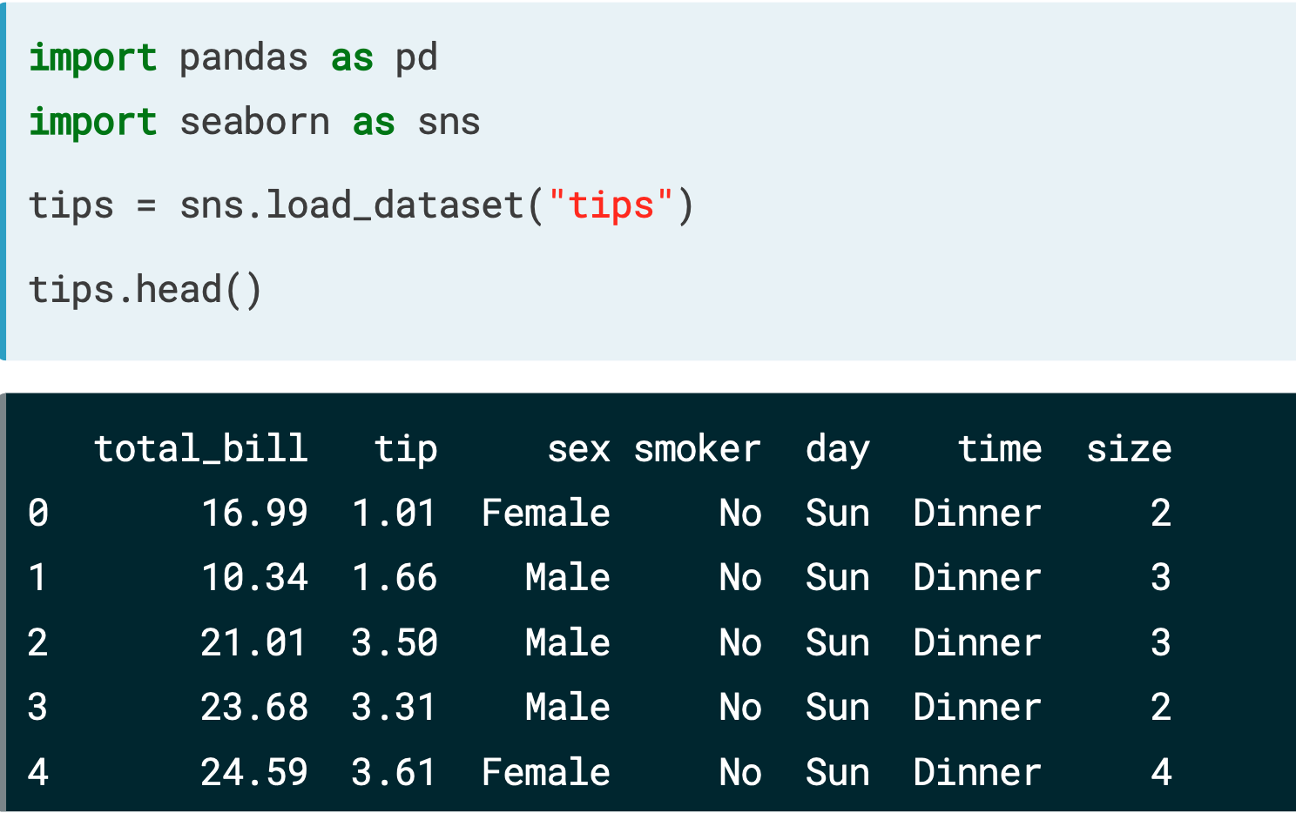

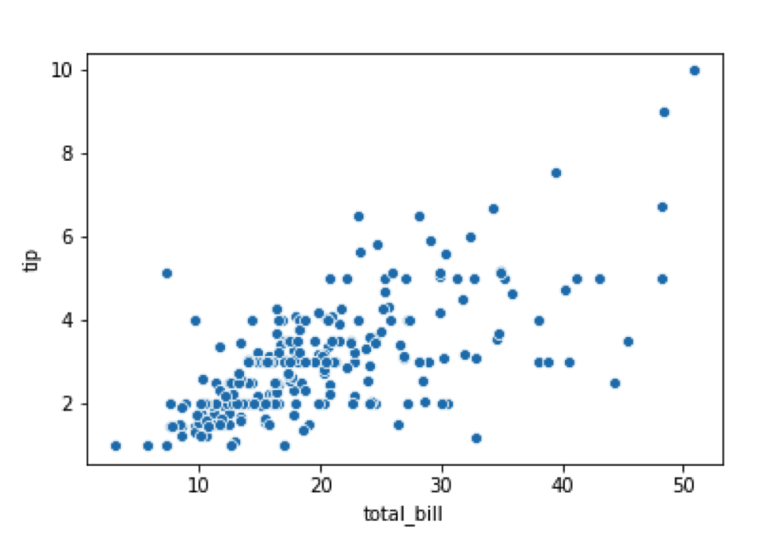

Q3) Which one of the following codes will produce the plot above?

A: sns.scatterplot(x="total_bill", y="tip", data=tips)

B: sns.counterplot(x="total_bill", y="tip", data=tips)

C: sns.jointplot(x="total_bill", y="tip", data=tips)

D: sns.kderplot(x="total_bill", y="tip", data=tips)

Ans: A

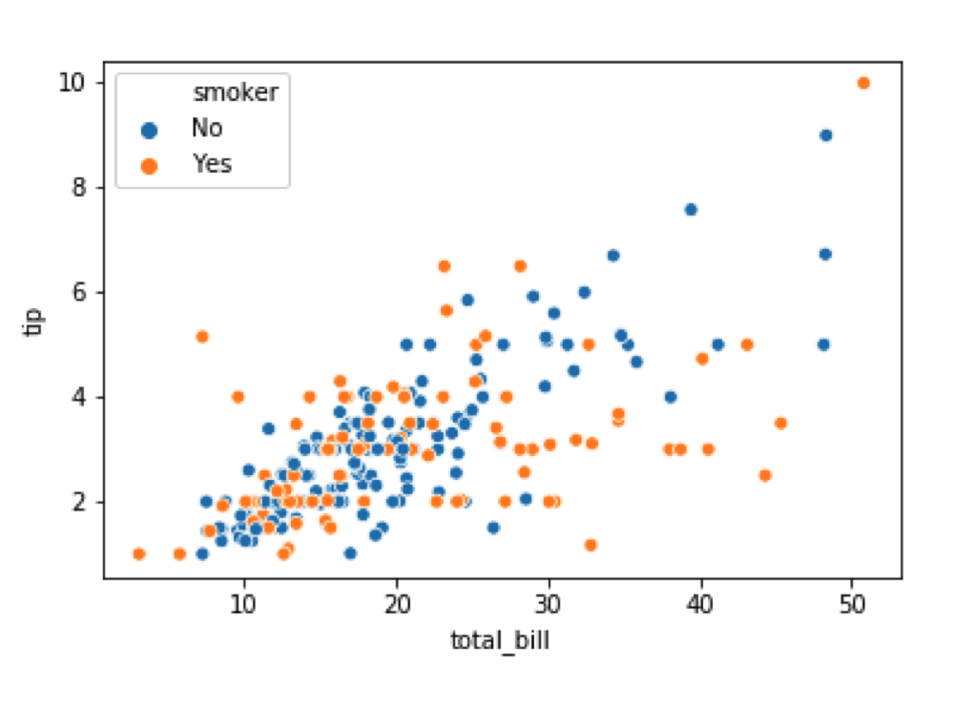

Q4) Which one of the following codes will produce the plot above?

A: sns.scatterplot(x="total_bill", y="tip", data=tips)

B: sns.scatterplot(x="total_bill", y="tip", data=tips, hue="smoker")

C: sns.scatterplot(x="total_bill", y="tip", data=tips, hue = “sex”,hue_order=["Yes","No"])

D: sns.scatterplot(x="total_bill", y="tip", data=tips, hue = “sex”)

Ans: B

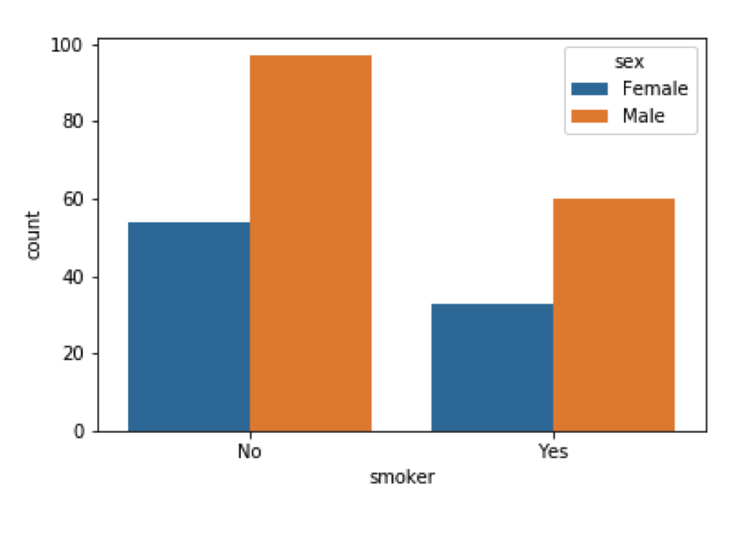

Q5) Which one of the following codes will produce the plot above?

A: sns.countplot(x="sex", data=tips, hue="smoke")

B: sns.countplot(x="smoker", data=tips, hue=[‘male’, ‘female’])

C: sns.countplot(x="smoker", data=tips)

D: sns.countplot(x="smoker", data=tips, hue="sex")

Ans: D